Resilient CI/CD Pipeline: An Intelligent Approach to Failure Recovery

1. Project Title
CI/CD Pipeline Automation with Intelligent Failure Recovery

2. Project Goals
The primary goal of this project is to develop a highly resilient Continuous Integration/Continuous Deployment (CI/CD) system capable of:
- Streamlining and automating the entire pipeline execution process.
- Proactively detecting and isolating failures during execution.
- Employing a hybrid classification strategy (rule-based and Machine Learning) to accurately categorize errors.
- Generating precise, actionable recommendations for recovery.
- Maintaining comprehensive execution logs and preserving system state for auditing and analysis.

3. Overview
CI/CD is a foundational practice in modern software development, automating the progression of code from integration through testing and deployment.
This project introduces a sophisticated, simulated CI/CD pipeline that moves beyond simple execution. It is engineered to intelligently manage and respond to failures. Unlike conventional pipelines that halt upon encountering an error, our system detects the issue, classifies its root cause, and provides intelligent recovery suggestions, thereby significantly enhancing system robustness and developer efficiency.

Our folder structure looks like the following :

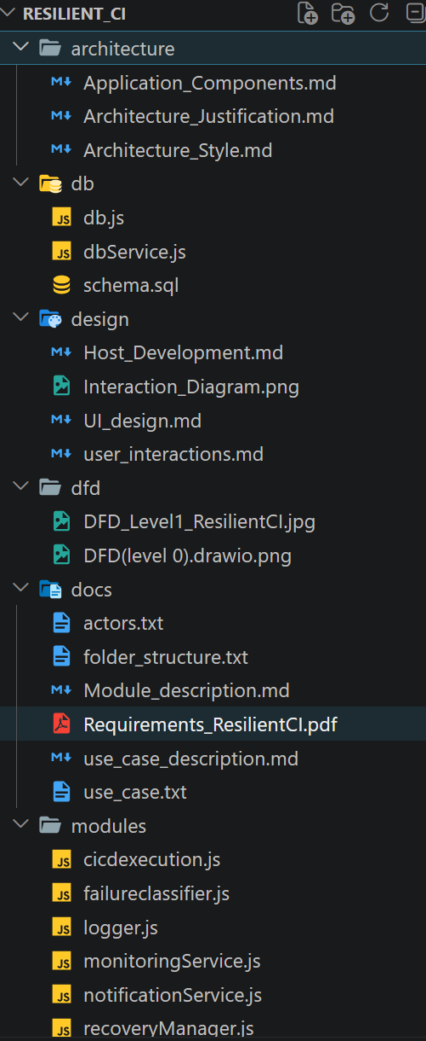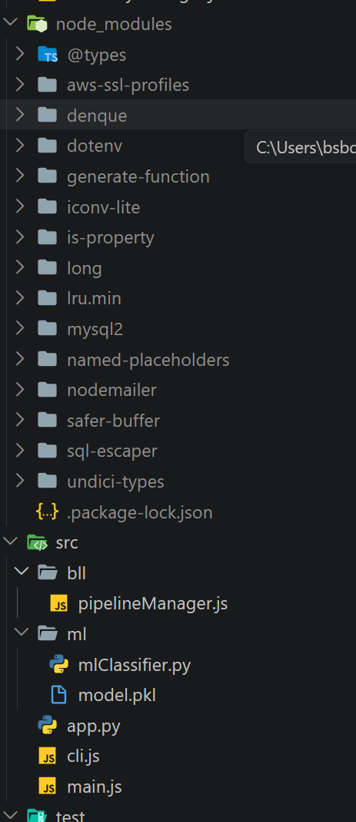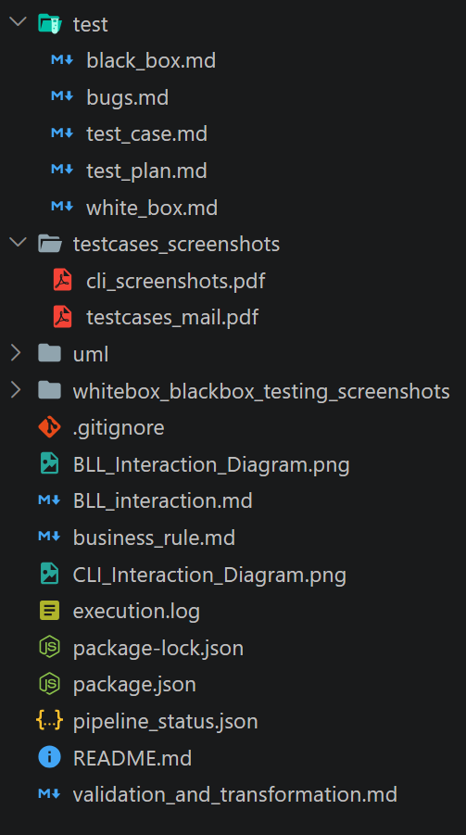

Our project is asserted in the following GitHub Repository.

4. System Architecture
The system is structured into cohesive modules that manage the execution flow, error handling, and data persistence:
Command Line Interface (CLI Module - cli.js)
The primary user interaction point, offering the following commands:
- run: Initiates the pipeline execution.
- status: Provides the current status of the pipeline.
- logs: Displays historical execution details.

Pipeline Execution Engine (cicdexecution.js)
Responsible for executing the target application (app.py). It utilizes a child process mechanism to isolate execution and returns a clear SUCCESS or FAILURE status.

Business Logic and Orchestration Layer (pipelineManager.js)
The core control unit, responsible for orchestrating the entire process flow, including:
- Execution initiation and management.
- Real-time error detection.
- Invoking the classification system.
- Managing recovery suggestions.
- Coordinating logging activities.

Failure Classification System (mlClassiier.py)
Employs a dual-methodology approach for high-accuracy error identification:
- Rule-Based Classification: For known and predictable error patterns.
- ML-Based Classification: To handle novel or complex, unstructured error messages.

Defined Error Categories:
- SYNTAX_ERROR
- LOGIC_ERROR
- DEPENDENCY_ERROR
- ENVIRONMENT_ERROR
- NETWORK_ERROR
- ML_CLASSIFIED_FAILURE (for errors categorized by the ML model)

Machine Learning Model (Python)
A dedicated Python module for processing and classifying previously unseen error log data. It is constructed using:
- TF-IDF Vectorization: To convert text logs into numerical features.
- Logistic Regression: The classification algorithm for robust prediction.

Recovery Suggestion Manager
Analyzes the classified error type and generates prescriptive recovery actions, such as:
- Syntax Error: Recommendation to review and correct the code.
- Dependency Error: Suggestion to install missing packages/modules.
- Environment Error: Instructions to verify system configuration settings.

Database Service (dbService.js)
Manages persistent storage for critical system information:
- Current and historical pipeline status.
- Comprehensive execution logs.

Logging and Monitoring
A dedicated component for tracking system activity, internal operations, and the execution flow, ensuring full traceability.

Notification Service
A communication module designed to alert users about pipeline status and failures (currently implemented via console output for immediate feedback).

5. Operational Workflow

The pipeline follows a clear, sequential path upon user command:
- User initiates the process via the CLI command.
- The Pipeline Execution Engine runs the target application (app.py).
- If an error is encountered, the system captures the failure.
- The Failure Classification System processes the error (Rule-based first, then ML if unknown).
- The Recovery Manager generates and outputs a suggested resolution.
- Execution details are persisted (file and database logs).
- A final notification is dispatched to the user.

6. Core Technologies
The system leverages a modern, polyglot technology stack:
- Node.js (for the core backend, CLI, and orchestration)
- Python (specifically utilized for the Machine Learning model with scikit-learn)
- MySQL (for persistent data storage)
- JavaScript (leveraging ES Modules for modularity)

7. Validation and TestingTesting Strategy:
The system was rigorously tested using multiple methodologies:
- Unit Testing: Verifying individual module correctness.
- Integration Testing: Ensuring seamless interaction between modules (e.g., Node.js and the Python ML module).
- Black Box Testing: Validating system functionality against specifications.
- White Box Testing: Examining internal structure and logic.
Key Test Scenarios:
Test Case | Scenario Description | Expected Outcome
TC01 | Pipeline completes without issues | SUCCESS status
TC02 | Introduction of a syntactic mistake in the code | SYNTAX_ERROR classification
TC03 | Attempting to import a non-existent software package | DEPENDENCY_ERROR classification
TC04 | Running the pipeline with inadequate user permissions | ENVIRONMENT_ERROR classification
TC05 | Introduction of a novel, previously unseen runtime error | ML_CLASSIFIED_FAILURE

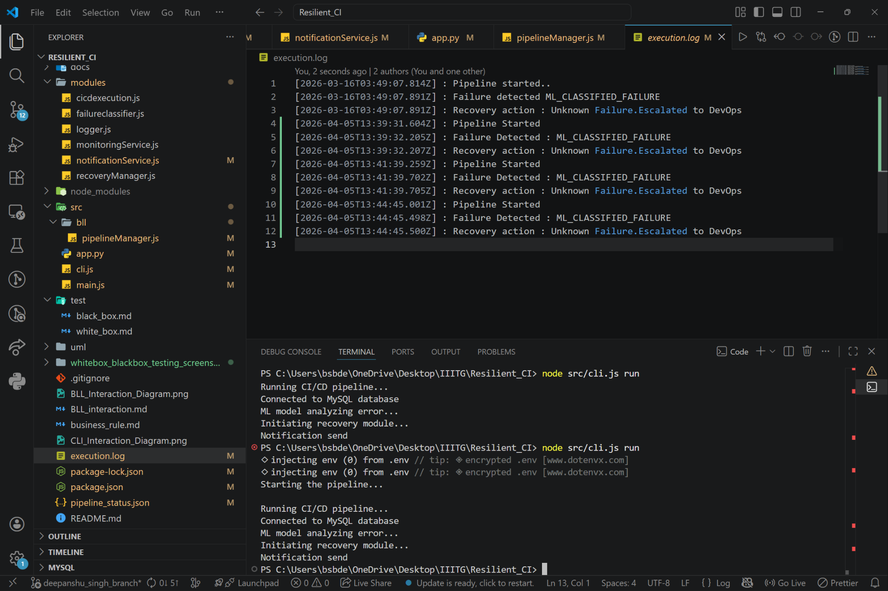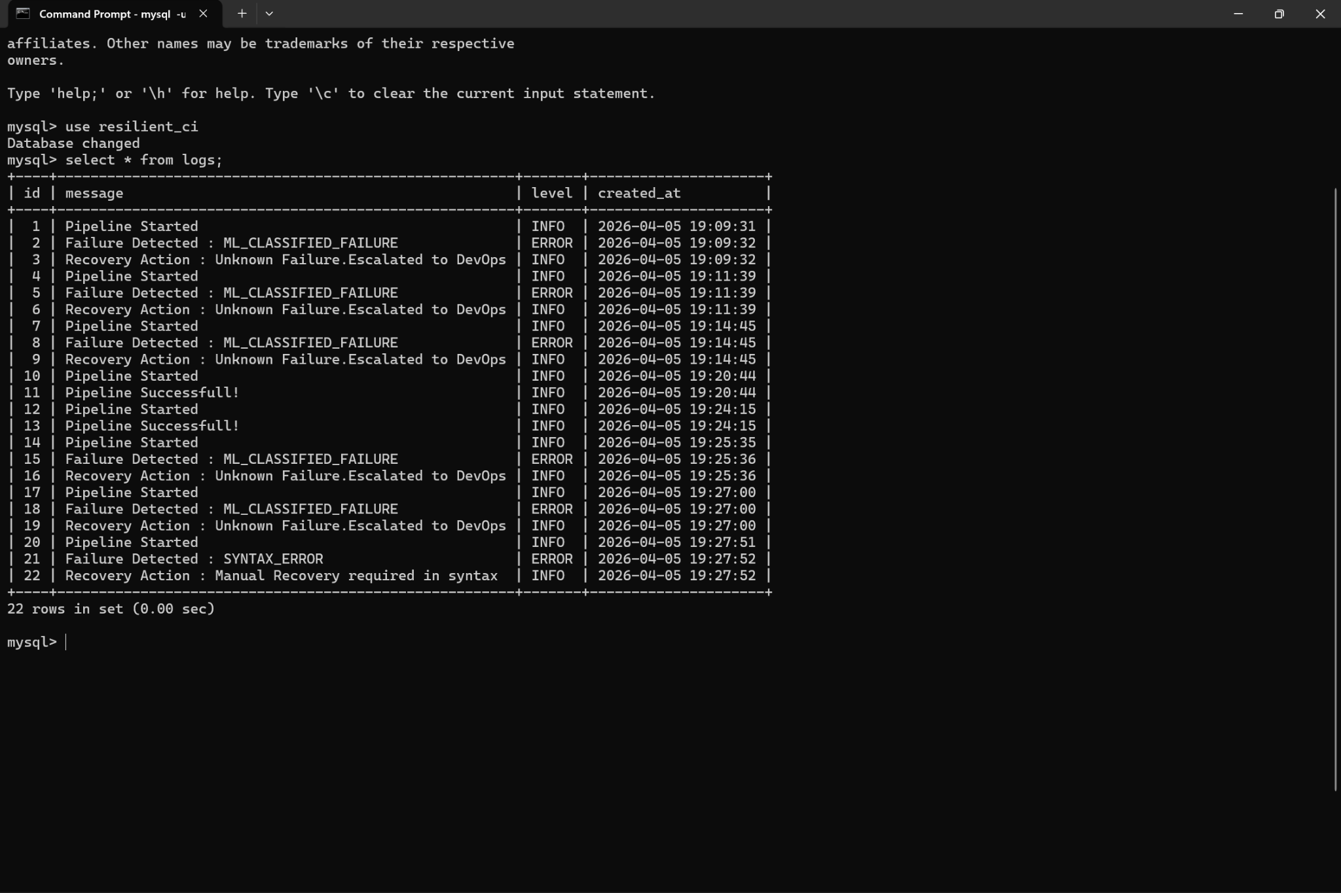

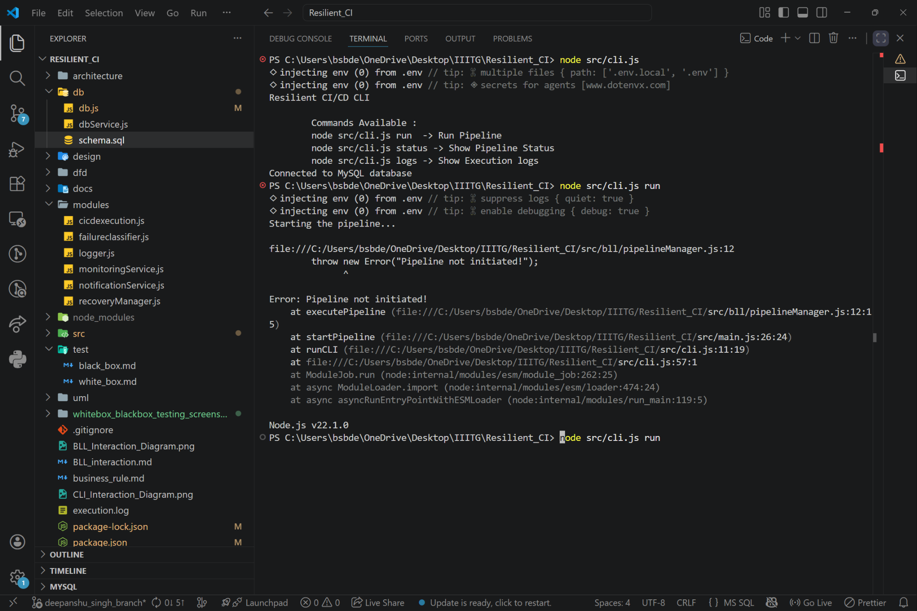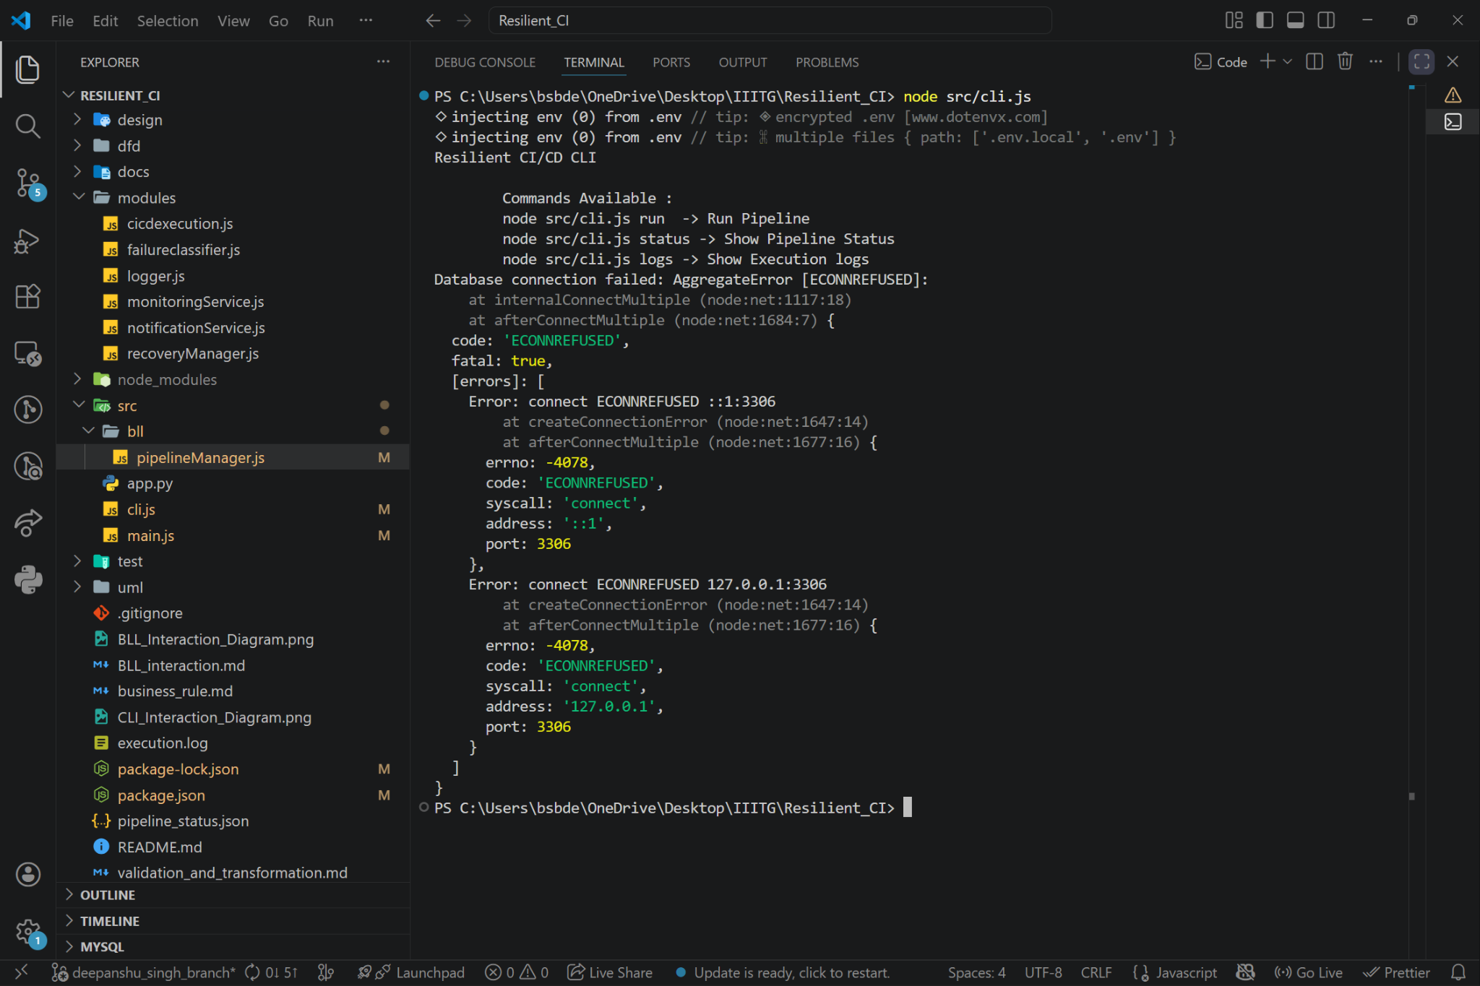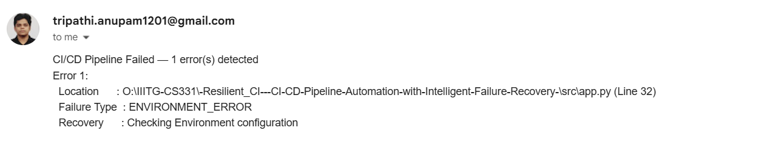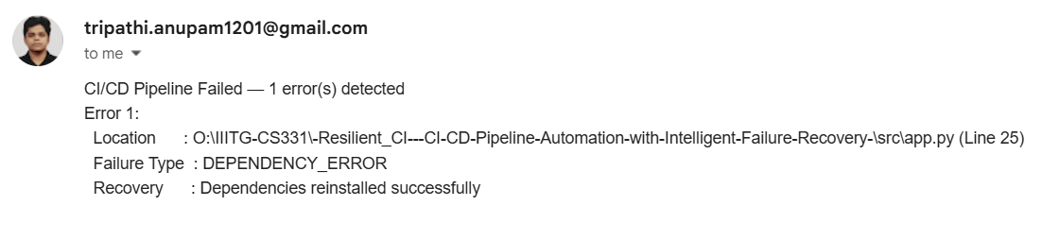

8. Bug Resolution and Refinement

During testing, several critical issues were identified and systematically resolved:
ID | Description | Severity | Fix Implemented
BUG01 | Asynchronous execution caused premature termination of the pipeline (non-blocking wait). | High | Enforced sequential execution using await executePipeline().
BUG02 | The internal path to the application file was incorrect, leading to "file not found" errors. | High | Corrected the file path to the definitive src/app.py.
BUG03 | Failure to establish a database connection due to missing configuration variables. | High | Ensured correct DB credentials were supplied via the configuration mechanism.
BUG04 | The intended external notification system (e.g., SMTP) failed due to network restrictions. | Medium | Reverted to using console.log for reliable, instantaneous alerts.
BUG05 | Ambiguous classification for unknown errors, often defaulting to the ML category without confidence. | Medium | Enhanced both the classification ruleset and the ML training dataset for improved precision.

9. Team Contributions
Anupam Tripathi (2301038)
- Pioneered the Pipeline Execution Engine implementation.
- Designed and developed the robust Command Line Interface (CLI).
- Resolved critical asynchronous and concurrent execution issues.
Harshit Jain (2301090)
- Engineered the Machine Learning Model utilizing scikit-learn library for classification.
- Designed the integrated, hybrid (Rule + ML) error classification system.
- Managed the integration between the Python ML component and the Node.js backend.
Deepanshu Singh (2301073)
- Developed the persistent Database Module and Service layer.
- Implemented comprehensive Logging and Monitoring functionalities.
- Executed the systematic creation of test cases and formalized bug reports.

10. Conclusion
This project successfully delivered a working prototype of a resilient CI/CD system. It serves as a proof-of-concept demonstrating the effective integration of DevOps principles with Machine Learning for enhanced fault tolerance. The system successfully automates execution, accurately detects and classifies errors, and provides actionable recovery suggestions, showcasing its potential for integration into real-world, production environments.

11. Future Development Roadmap

To transition this prototype into a full-featured system, future work will focus on:
- Implementing robust, real-time external notifications (e.g., email, Slack integration).
- Exploring advanced Deep Learning models (like LSTM or BERT) for more sophisticated error log analysis.
- Developing a user-friendly Web Dashboard for visualization and interaction.
- Integrating an Automated Recovery Execution module to apply suggested fixes without manual intervention.

